Power BI Assignment 2 – DAX & Data Visualization
Name: HARITHA HARI
Batch: 69

Create a Calculated Column for 'Category Type':

Add a calculated column in the Order Details table that combines the 'Category' and 'Sub-Category' columns into a single 'Category Type' column.
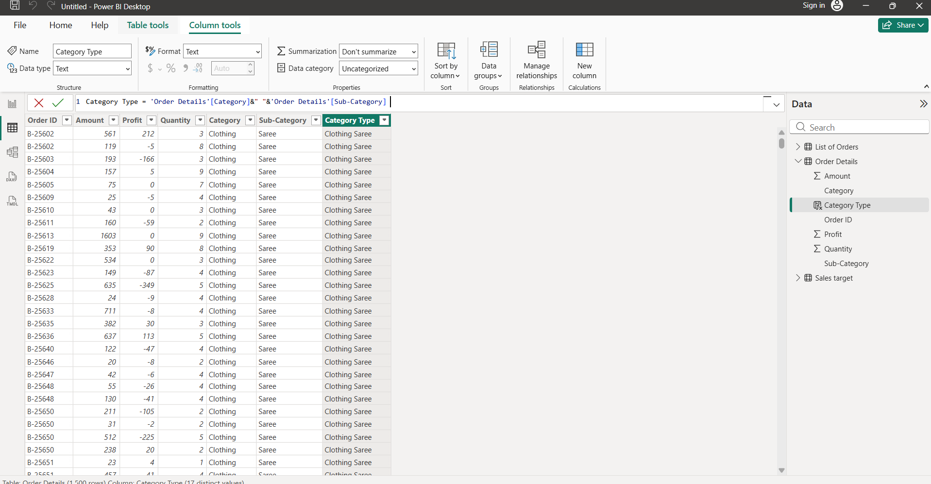
Calculate Revenue per Order in Order Details Table:

Create a calculated column in the Order Details table to compute the revenue (Amount * Quantity) per order.
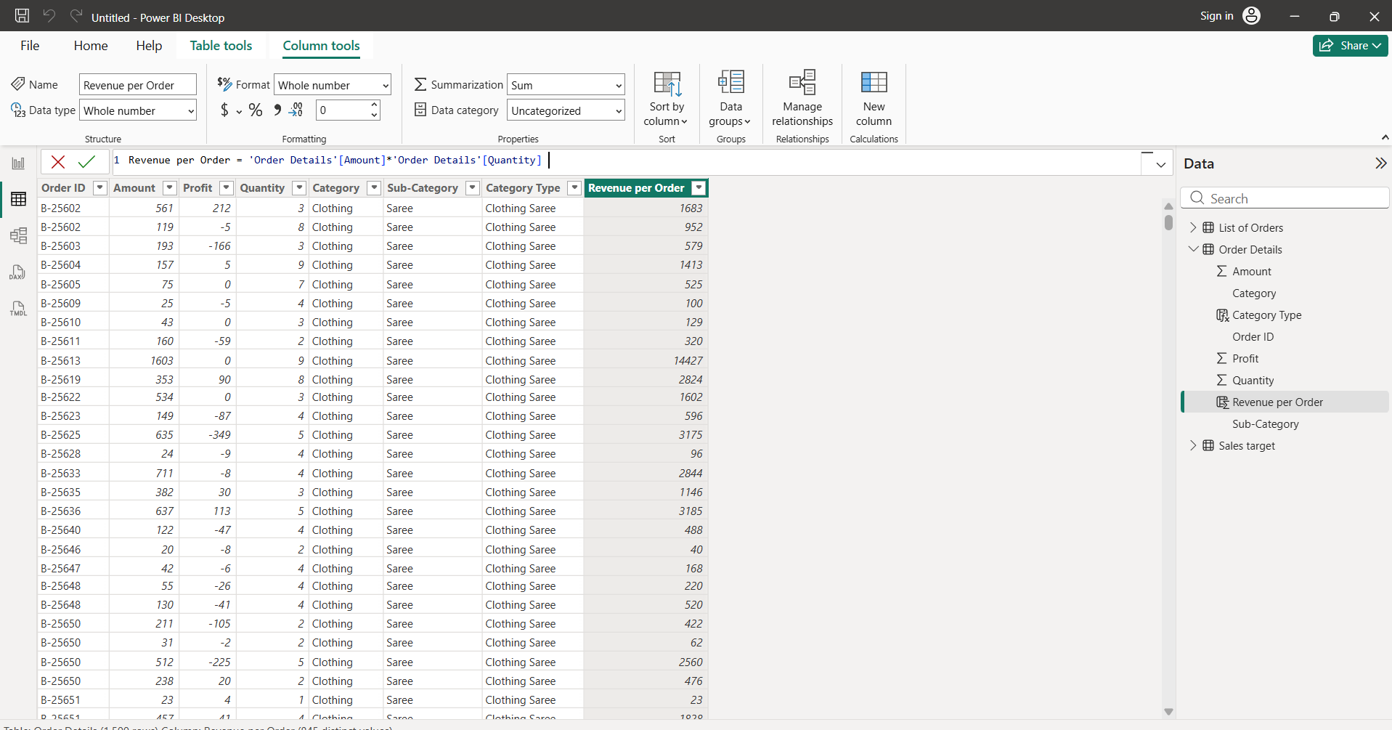

Create a Calculated Column to Categorize Sales:

Add a calculated column named ‘Sales Category’ in the Order Details table that categorizes each order as 'Above Average' or 'Below Average' based on the Amount value.
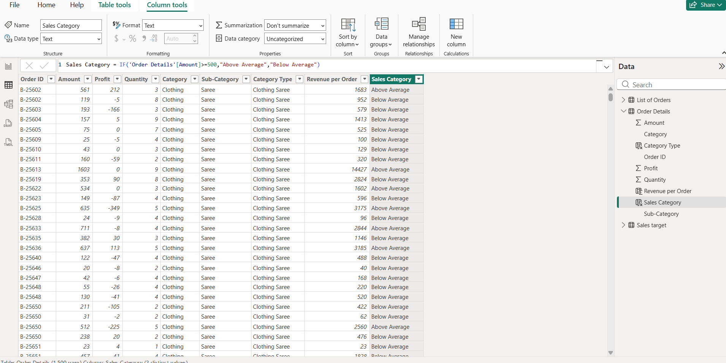

Calculated Measures:

Calculate Order Count:
Define a measure to count the total number of orders in the Order Details table.
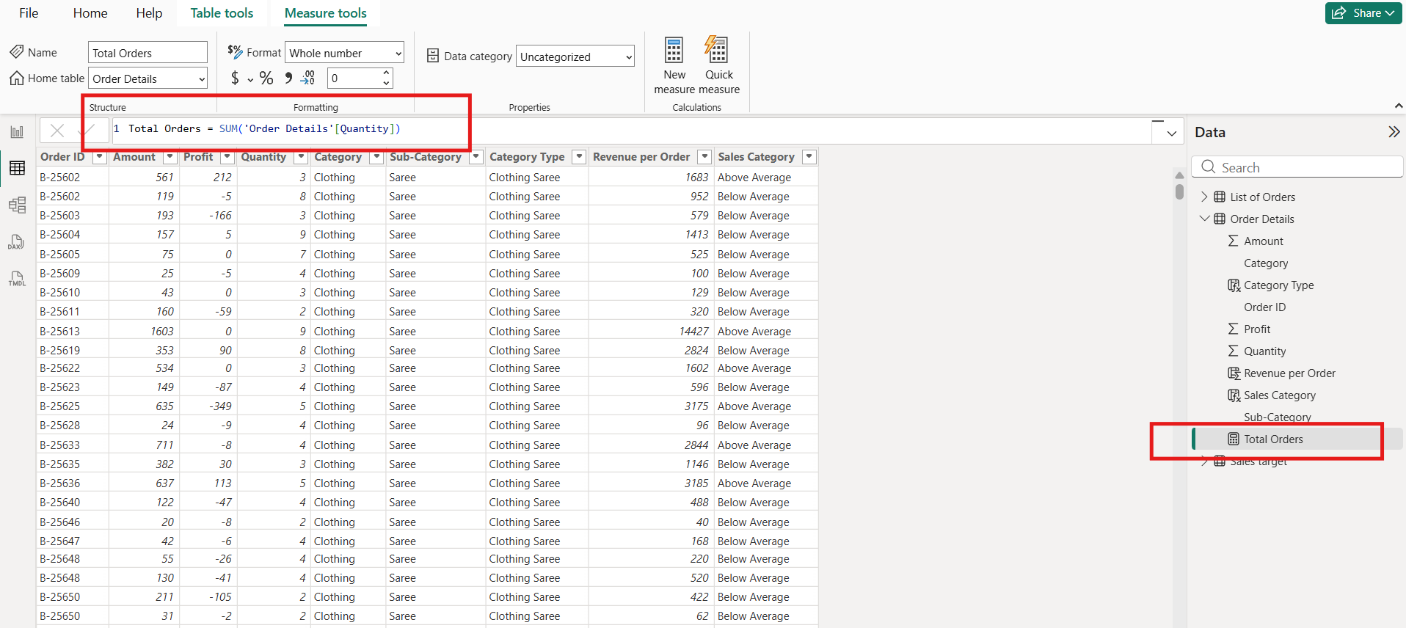
Calculate Average Profit in Delhi:
Create a measure to calculate the average profit for orders placed in Delhi.
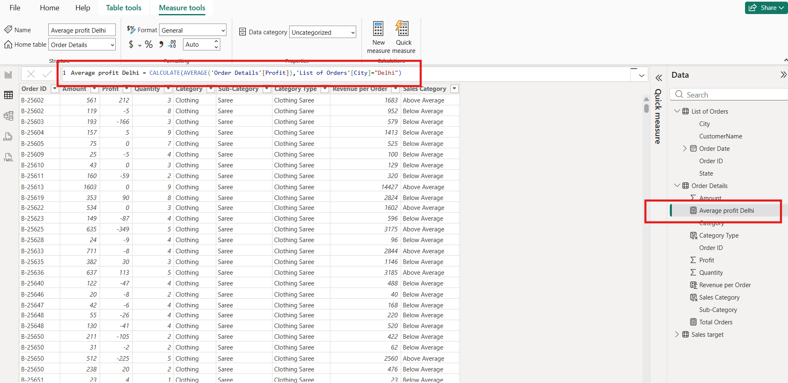

Calculate Year-to-Date (YTD) Sales:
Define a measure to calculate the total sales amount accumulated from the earliest order date up to each order date.
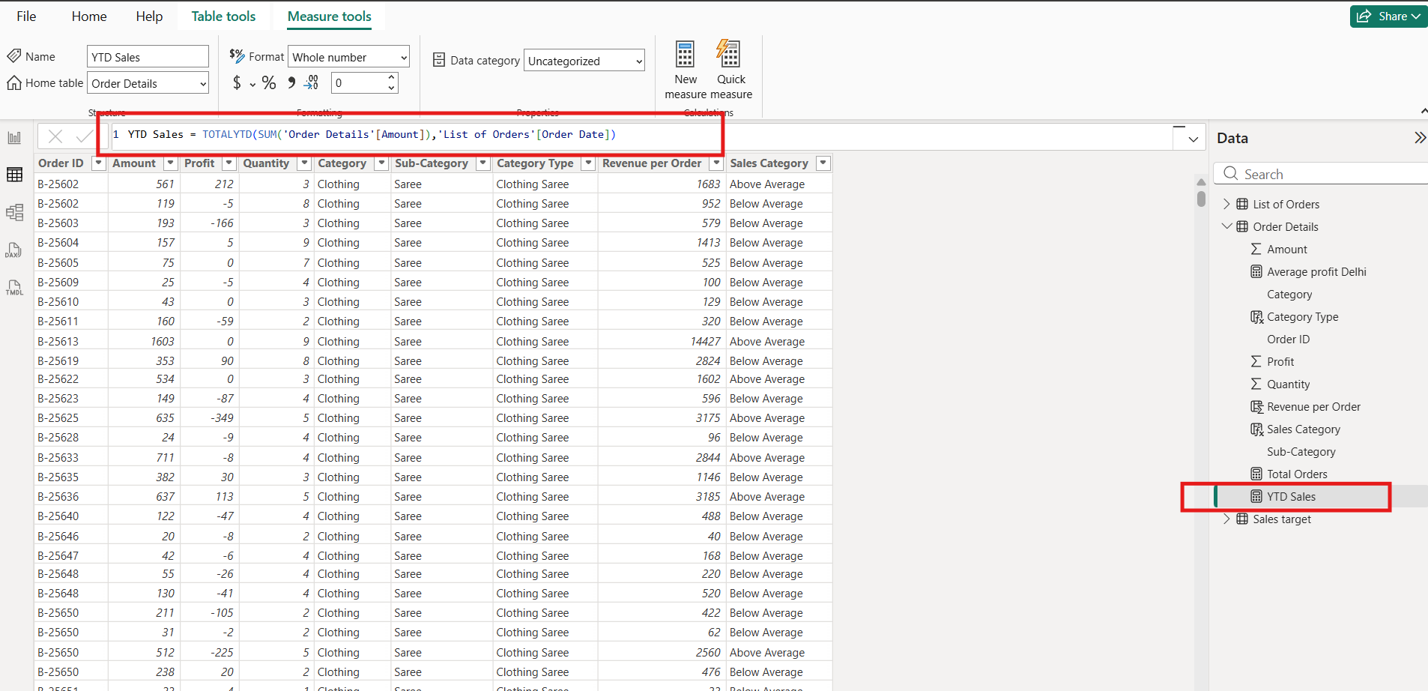

Data Visualization:
Sales Target Achievement by Category:
Compare actual sales with sales targets by category using a clustered column chart.
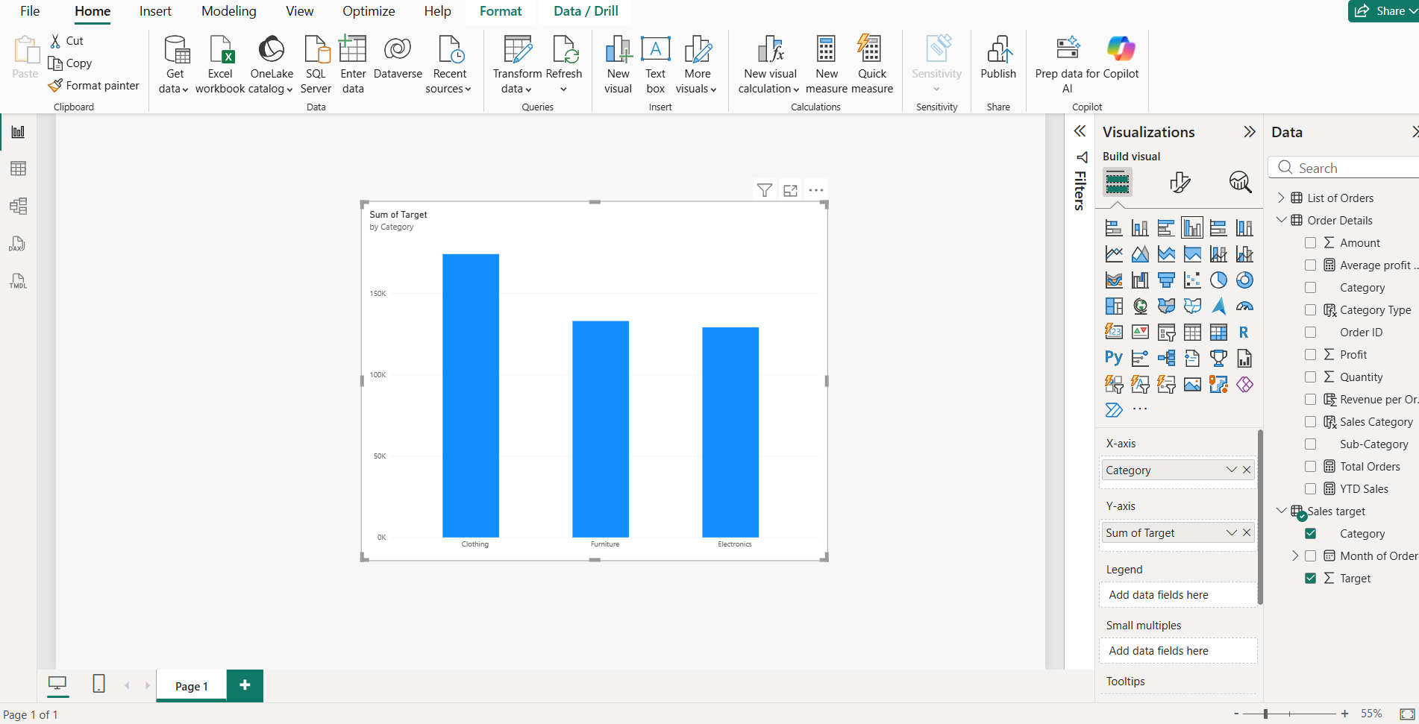

Max Profit Margin by Sub-Category:
Analyse the maximum profit margin for each sub-category of products using a donut chart.
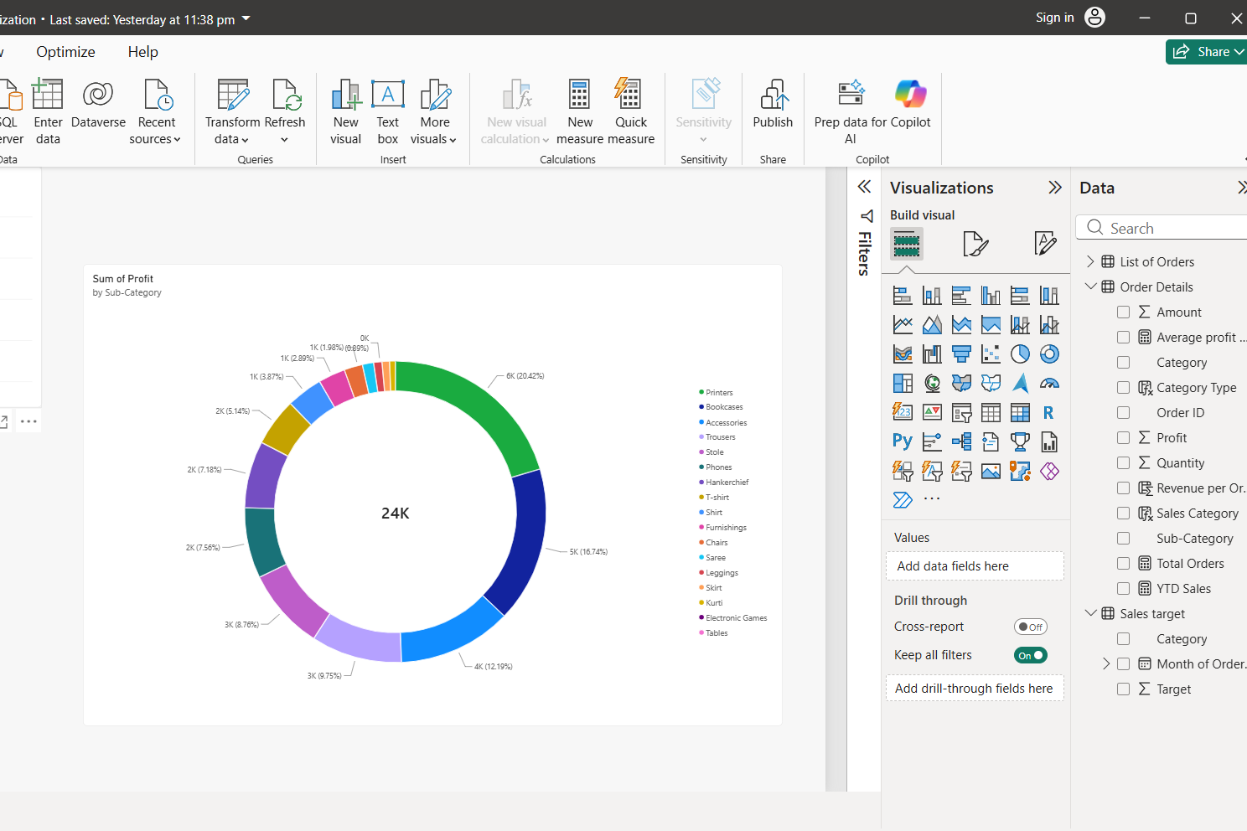
Monthly Sales Trend:
Show the trend of monthly sales over time using a line chart.

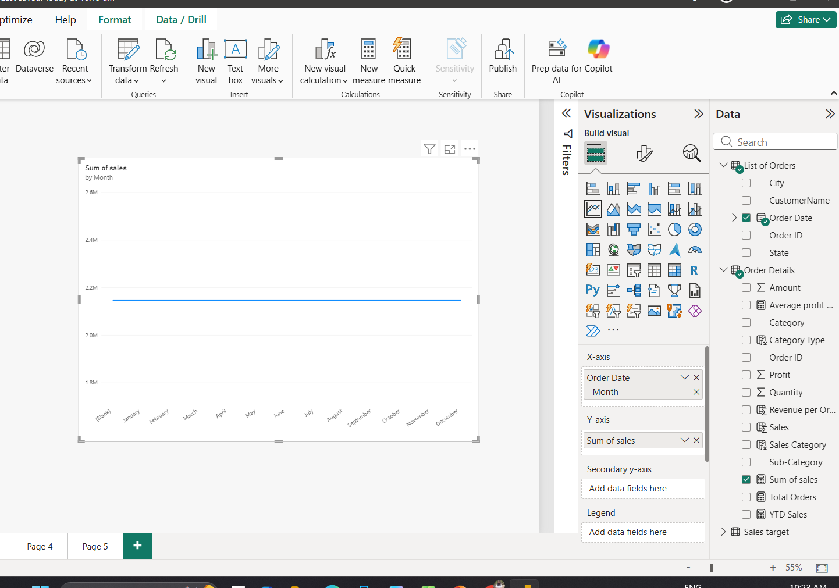
Comparison of Profit and Quantity by Sub-Category:
Compare the relationship between profit and quantity sold for different sub-categories using a scatter chart.
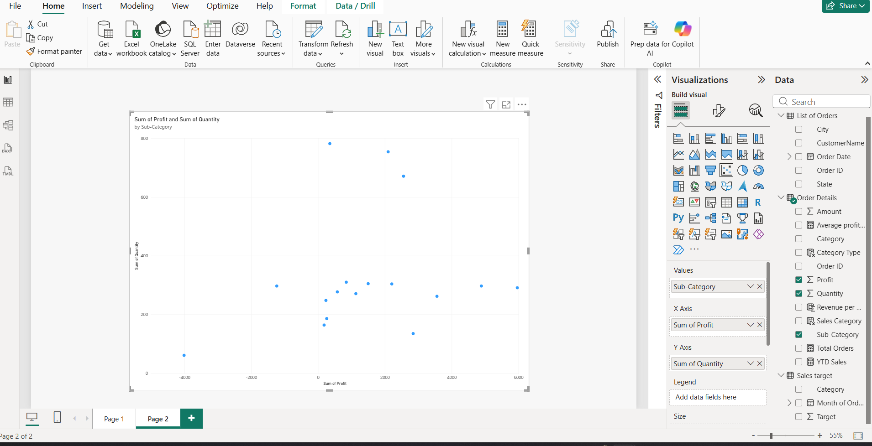
Comparison of Total Sales Amount and Target:
Create cards to succinctly display the total sales amount alongside the sales target for quick comparison and analysis. Also, create a multi-row card to display the minimum target for each segment.

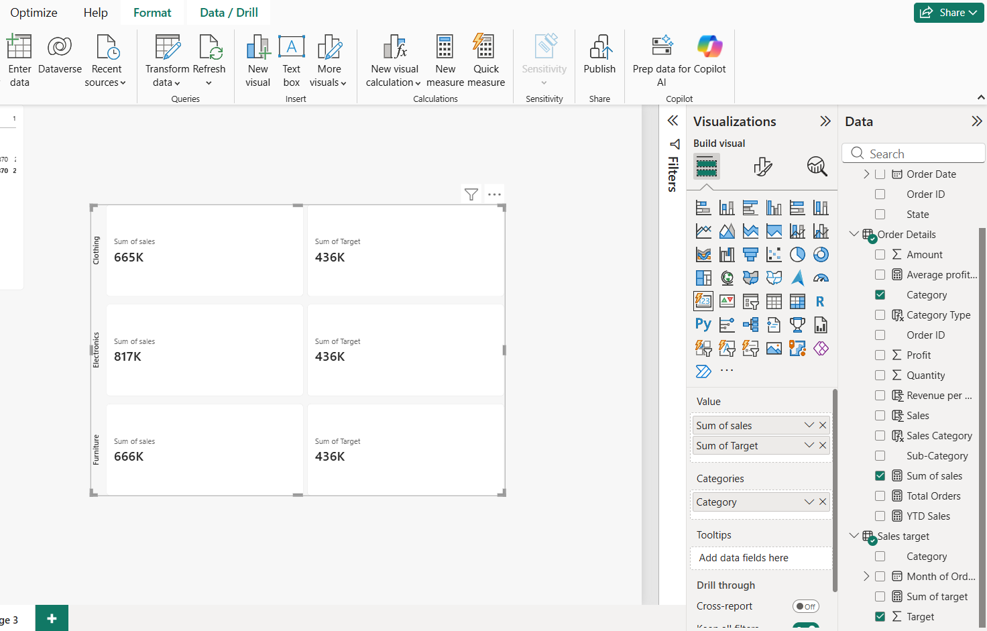

Sales Performance Matrix:
Build a matrix view to analyse how actual sales compare to sales targets across different categories and months.
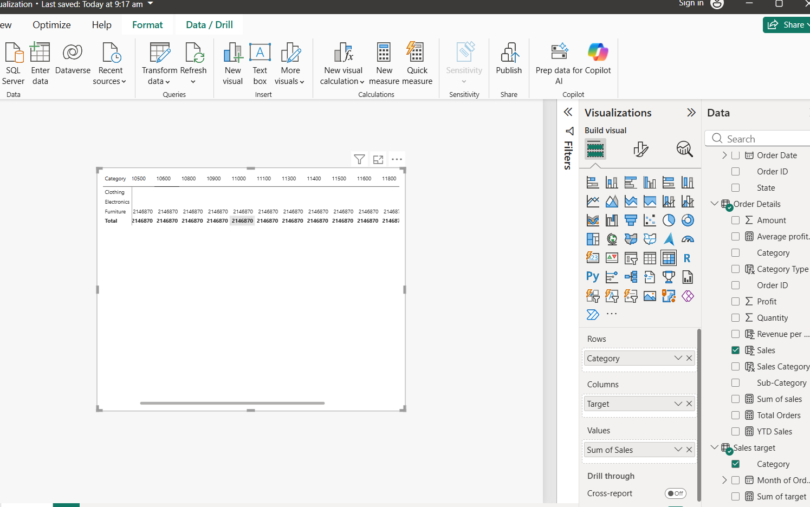
Geographic Sales Analysis:
Visualize total sales on a map by city to identify regional sales patterns.
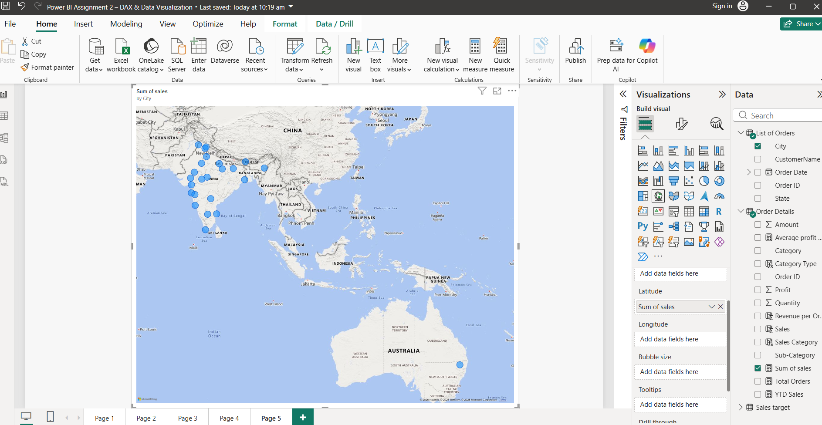

Sales Distribution by Sub-Category:
Represent the sales distribution across different sub-categories using a tree map.
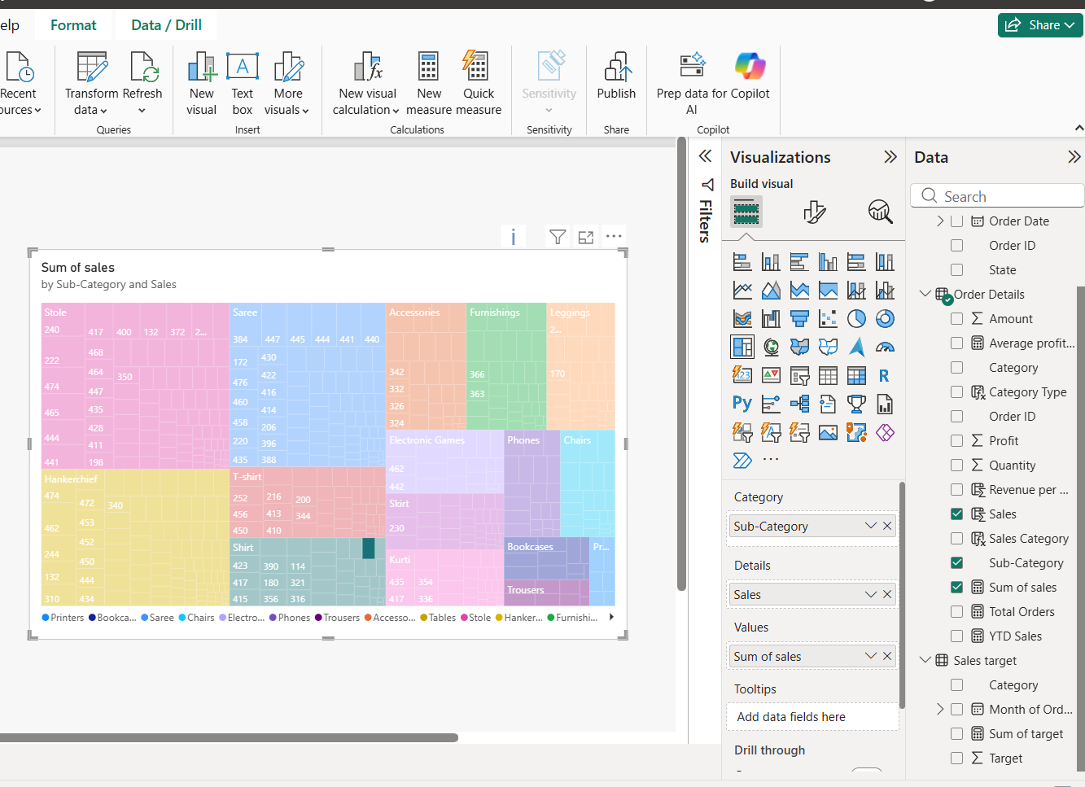
Order Count Analysis by State:
Create a funnel chart to visualize the distribution of order counts across different states.
